P02 Assignment 1-Configuration Management

Objectives

- Create repository for version control and team access
- Working as a team for configuration management

Tasks

Background of Version Control / Subversion

We will be using one of the most popular version control systems called Subversion. This system is used widely in the industry. Visit the Subversion Wikipedia Page (http://en.wikipedia.org/wiki/Apache_Subversion), spend a few minutes to browse through the origins and background of the system.

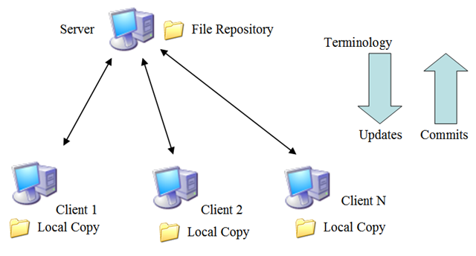

How Subversion works:
- One member (E.g. Client 1) will upload the project into the repository server.
- The other members (E.g. Client 2… N) will download the project in their own PCs.
- The entire team will collaborate and make changes with the repository server. Subversion will have mechanisms to ensure changes are saved onto the server and that conflicts must be resolved by the team.
Terminology Used:
- Repository: The database server storing the project.
- Local Copy (Working Copy): The version of the project on each Client PC.
- Commit Changes: Transfer changes made in the Local Copy into the Server File Repository.
- Update Changes: Get the latest changes from the Server File Repository onto your Local Copy.

Activity 1

There are free repositories out there that allow teams to store their codes online. We will be using the Google Code Hosting service (http://code.google.com/hosting/).

- For the rest of this session, work together in your project group:
  - Nominate a team leader, he or she will be the one that creates the repository on Google Code. The rest of you will act as team members.
  - The leader and all members must have an existing Google account..

- Go the Google Code Hosting page (http://code.google.com/hosting/) and sign in with your Google account (if you have not yet done so).

- The team leader should create a new repository for your project. Click on “Create a new project”.

- Fill up the form accordingly:
  - The Project Name must be a unique name in Google Code Hosting.
  - Fill up the Project Summary / Project Description with a brief description of your project.
  - Version Control System – Subversion
  - Source Code License – Any, but you can choose “GNU GPL v3”. To use Google Code Hosting, your codes need to use one of these open source licenses.

- Click on “Create project” and you will see your newly created project page as shown below. Feel free to explore the various sections of the project page. You can use the Wiki and other sections to communicate to each other as you build your assignment.
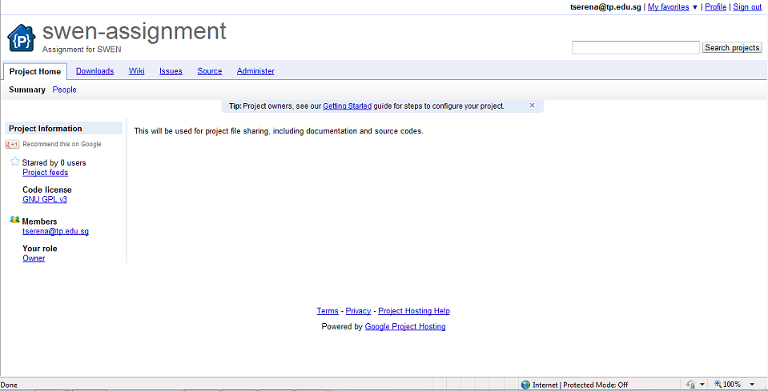

- The team leader should now add the rest of the team, and grant them permission to the project page. Go to Administer > Sharing. Add the email accounts of the remaining members to the “Project Owners” text area. Separate each owner by a comma and a newline (as shown in the example below).
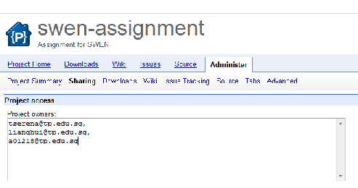

- Click on “Save changes” to confirm.
- The URL of the project home page will be based on the project name. If your project name is “swen-assignment”, the URL will be http://code.google.com/p/swen-assignment/. Get the rest of the members to access this URL.
- They should now be able to see all features of the project page, like the team leader. They can also access the list of projects they have access to by clicking on the “My favorites” drop-down at the top-right hand corner of the project page, as shown here.
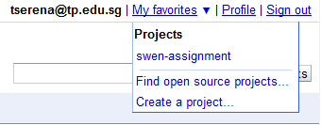

- The URL of the file repository is needed for your team to upload and makes changes to your codes. Click on Source > Checkout. Look for the repository URL as shown in the red rectangle, in the example below. You also need to generate your googlecode.com password to have write-access to the repository.

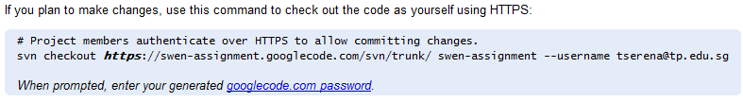

- Finally, before we end this part, write down the details for your project below. You will need them later to communicate to the repository.
What is the URL of your project home page? | http://
What is the URL of your repository? | https://
What is your googlecode.com password?

Activity 2

It is a good practice to exercise version control for all your project files, including documentation and source codes. The subversion repository which you had created in Activity 1 can be accessed directly from your Windows Explorer through the use of a software known as TortoiseSVN.

TortoiseSVN provides you with the below options when you right click on a specific folder in Windows Explorer upon successful installation.

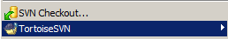

Network Settings

- If you are accessing your repository via TP network, please make sure that the proxy server settings are in place. You can have this done by doing a right click anywhere in your Windows Explorer to bring up the TortoiseSVN options.

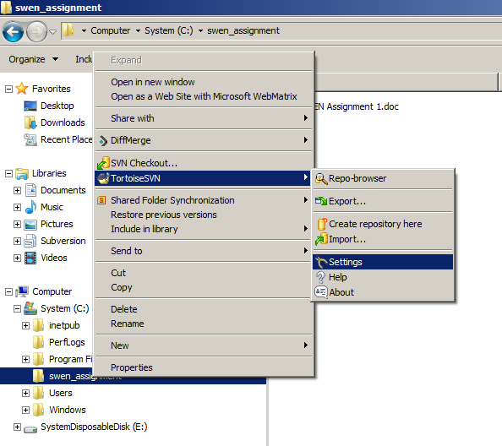

- Click on TortoiseSVN -> Settings. You should see the below window:

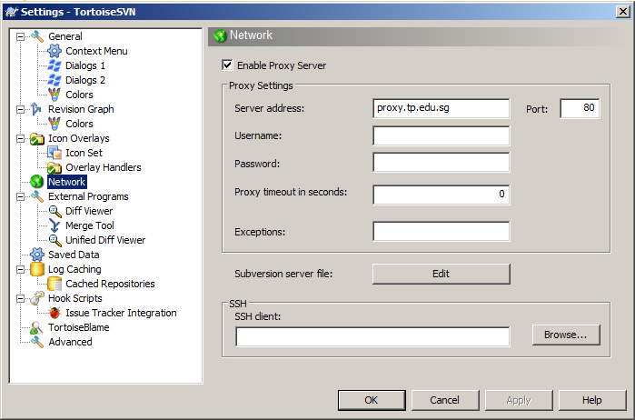

- Select “Network” in the left panel.

- Enter “proxy.tp.edu.sg” for Server address and “80” for Port in the right panel.

- Click “OK” once done.

* Note: If you are NOT accessing the repository via TP network, please perform the appropriate settings for this accordingly.

Add Files to Repository

- In your Windows Explorer, do a right click on the folder that you would like to add to the repository. This folder should contain your assignment files. This will bring up the TortoiseSVN options for selection once again.

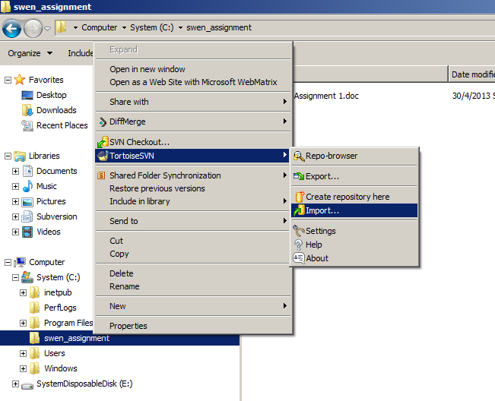

- Click on TortoiseSVN -> Import. You should see the below window:

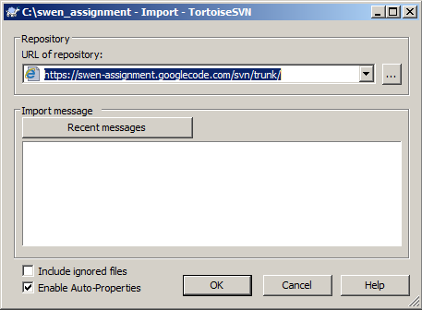

- Enter your Google Code Subversion Repository details (from Activity 1) in “URL of repository”.

- Click “OK” once done.

- You will be prompted for your username and password for your request to access your Google Code Subversion Repository. Enter these information accordingly. Note that your password is the one generated by Google Code in Activity 1.

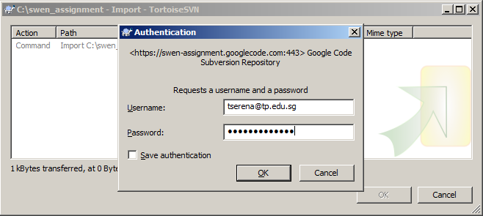

- Click “OK” once done.

- You will be informed on the outcome of the import. The screen below shows a successful import.

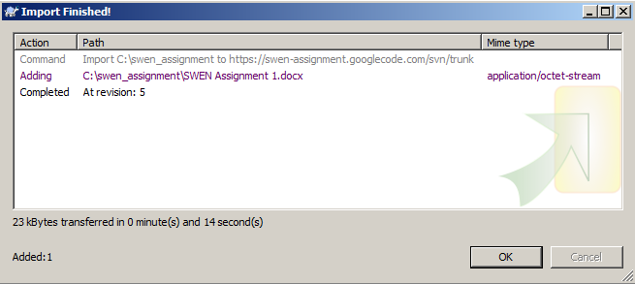

- Click “OK” once done.

View Files in Repository

- In your Windows Explorer, do a right click to bring up the TortoiseSVN options for selection once again.

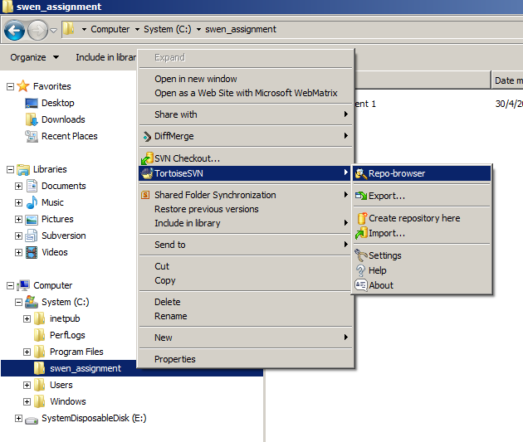

- Click on TortoiseSVN -> Repo-browser. You should see the below window:

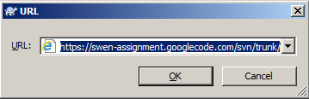

- Your Google Code Subversion Repository details should be auto-populated at this juncture. Please verify the information accordingly. If the details are incorrect, enter the correct details from Activity 1 accordingly.

- Click “OK” once done.

- You should see the file(s) which you had just imported to the Google Code Subversion Repository earlier in the window.

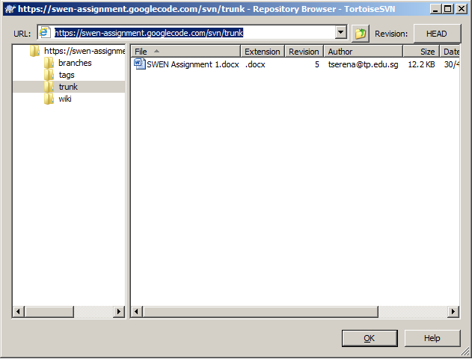

- You should see the file(s) which you had just imported to the Google Code Subversion Repository earlier in the window.

Delete Files from Repository

- Continuing from the previous section in your Repository Browser, you can actually delete a file from your Google Code Subversion Repository by doing a right click and select on “Delete” option. This serves for your information, and we will not be doing this for our exercise.
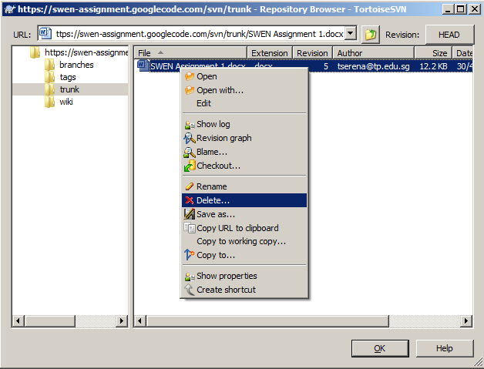

Check-out Files from Repository

- In your Windows Explorer, create a new folder to serve as your working copy. For this exercise, we shall name this folder as “svn_checkout”.

- Do a right click to bring up the TortoiseSVN options for selection once again.

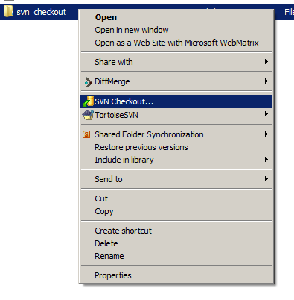
- Click on SVN Checkout. You should see the below window:
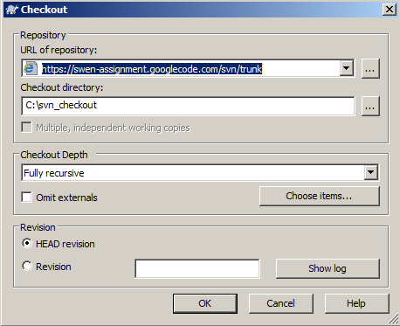

- Your Google Code Subversion Repository details should be auto-populated at this juncture. Please verify the information accordingly. If the details are incorrect, enter the correct details from Activity 1 accordingly.

- Click “OK” once done.

- You will be informed on the outcome of the checkout. The screen below shows a successful checkout.

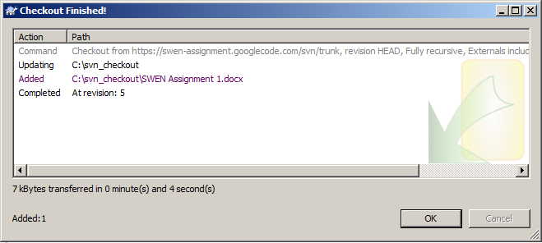

- Click “OK” once done.

- You will notice that the files in your Google Code Subversion Repository had been downloaded to your local machine to serve as your working copy. These files will have a green tick icon to indicate its version is the latest in the Google Code Subversion Repository.
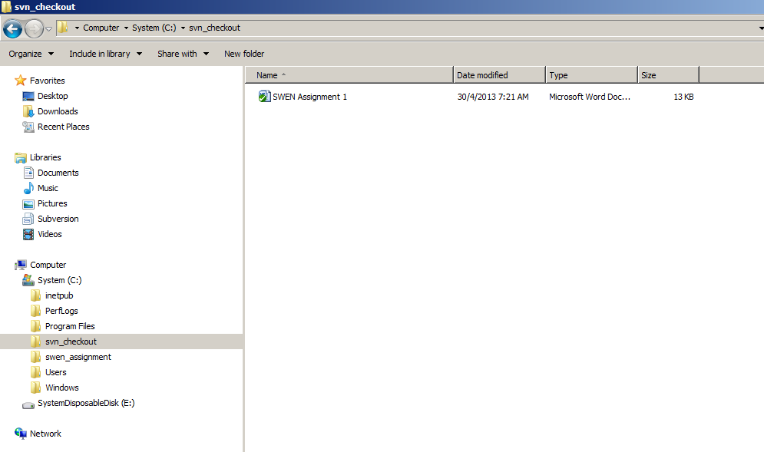

Modify File and Commit your change to Repository

- Once you made changes to the checkout file and save it, you will notice that the modified file will have an exclamation mark icon to indicate its change; differing it from the version in Google Code Subversion Repository.
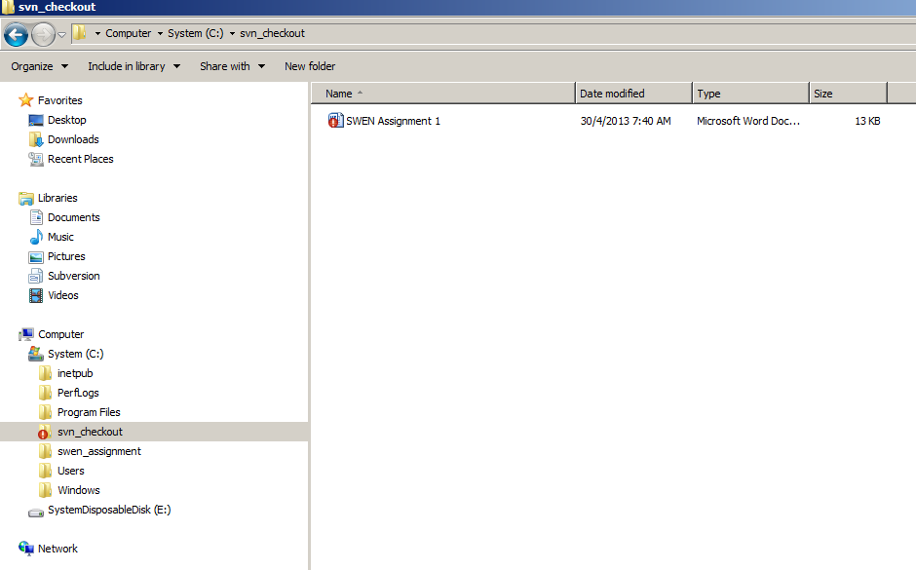

- In order to make the modified file available for all team members to use, you will need to commit your change. With this commit, the modified file will be uploaded to the Google Code Subversion Repository for your team member to access. You can perform the commit by doing a right click on the modified file.
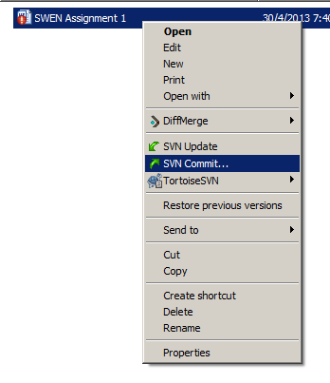

- Click on SVN Commit… You should see the below window:
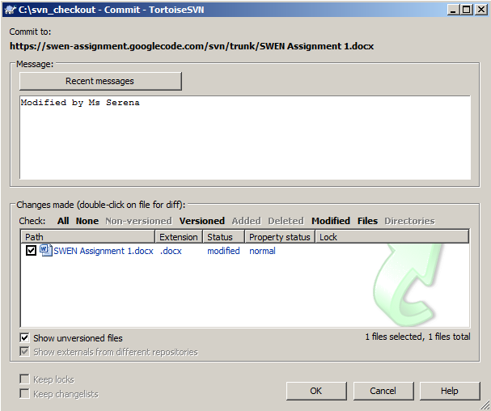

- Cultivate the habit to enter a message for every commit, so that all team members will know the change history of the file.

- Click “OK” once done.

- You will be prompted for your username and password for your request to access your Google Code Subversion Repository. Enter these information accordingly. Note that your password is the one generated by Google Code in Activity 1.

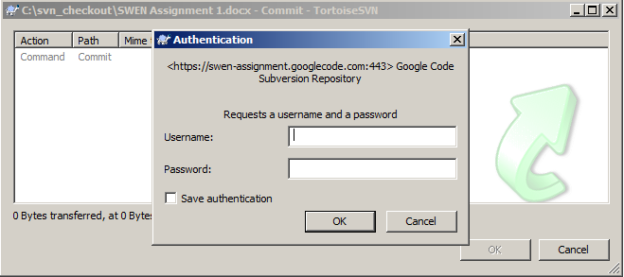

- Click “OK” once done.

- You will be informed on the outcome of the commit. The screen below shows a successful commit.
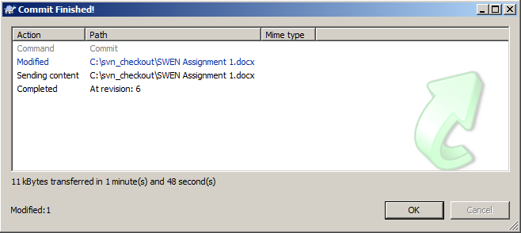

Note:

A conflict may occurs if Subversion detects that your working copy is not the latest version in the repository. You will be alerted in this case, and must resolve this before any commit can take place (i.e. it is a requirement that the working copy to be committed is up to date).

- Click “OK” once done.

- You will notice that the committed files will have a green tick icon to indicate that its version is the latest in the Google Code Subversion Repository.
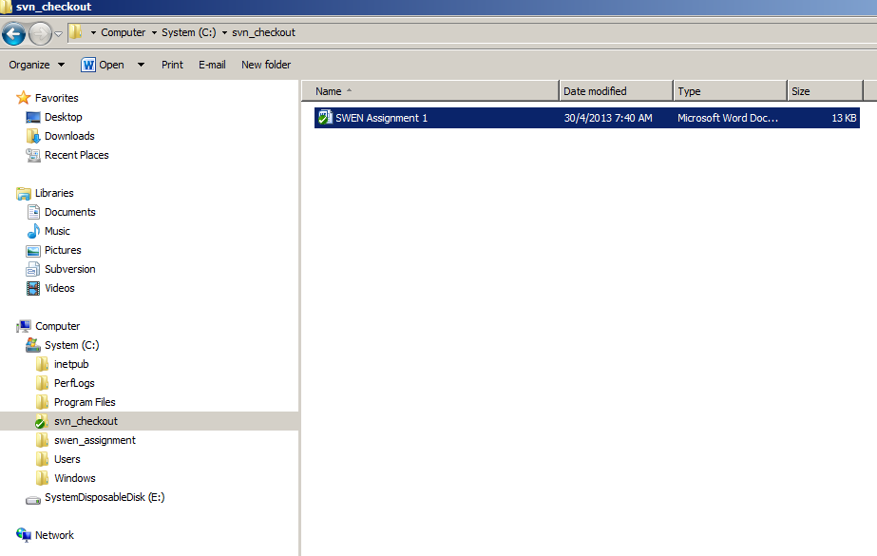

Last Note:

- You may have noticed another option TortoiseSVN->Export when you do a right click in Windows Explorer. How is this different from SVN Checkout option?

Though TortoiseSVN->Export option also allows you to download the files from the Google Code Subversion Repository, you will not be able to commit any modified file back to the repository readily, as this option did not generate the necessary hidden .svn directories and meta-data that makes it a working copy.

- You may have also noticed another option SVN Update when you do a right click in Windows Explorer on the selected file that you had checked out from the repository earlier. How is this different from SVN Commit… option?

SVN Update option also allows you to download the latest version of the existing working copy that is already checked out from the Google Code Subversion Repository previously. This option is useful as more often, there may be later version of the file in the repository that is committed by other team members compared to the version in your working copy.

***** End of Lab *****

